**EXPERIMENT-3-1**

GITHUB URL: https://github.com/kotadakshata15924/FEWD.git

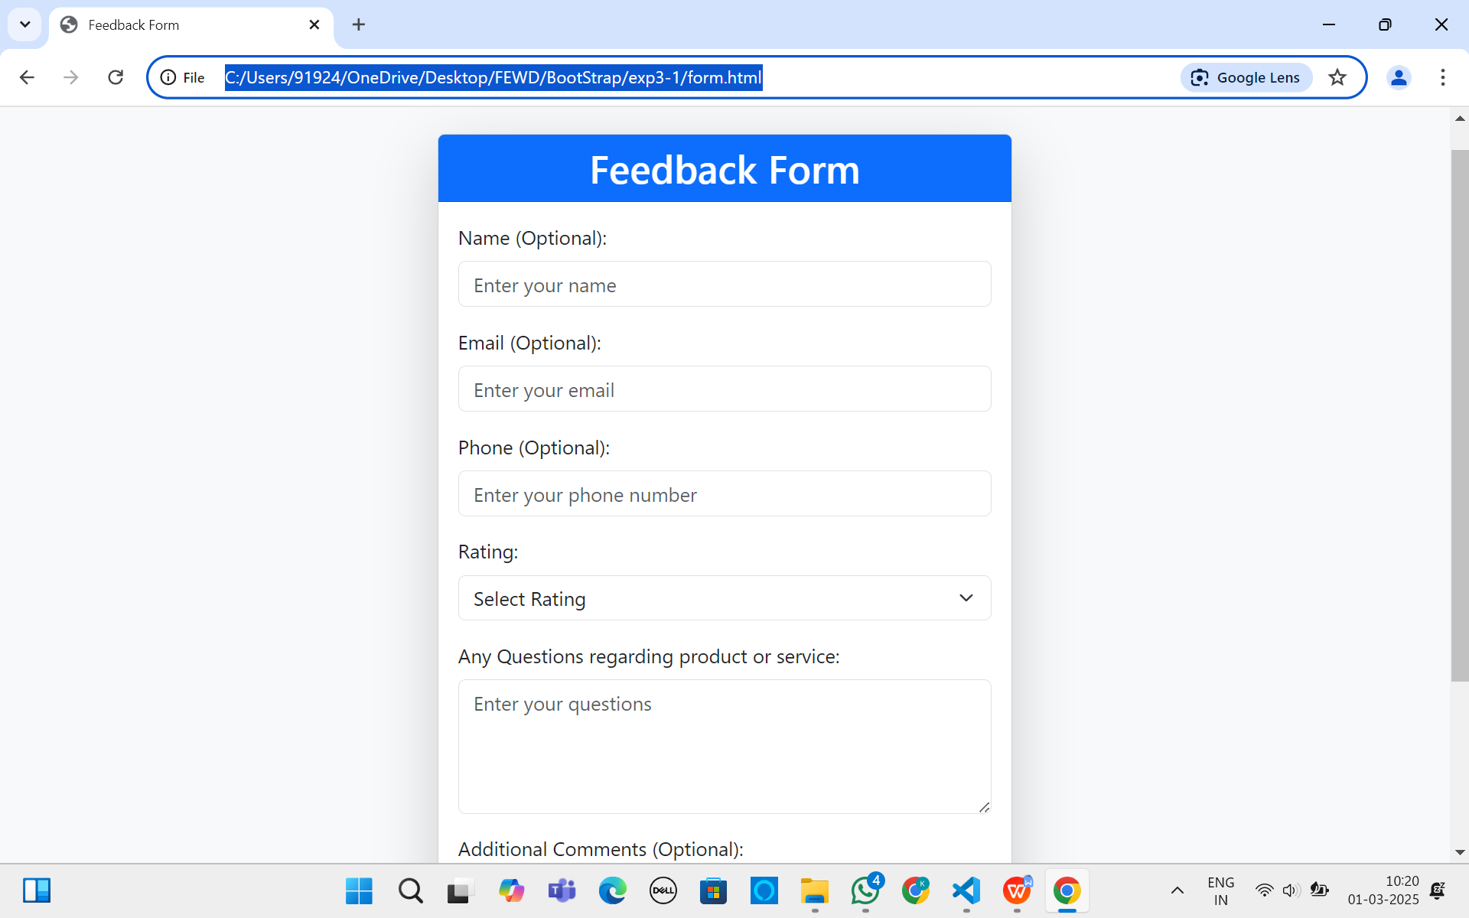

Portfolio

